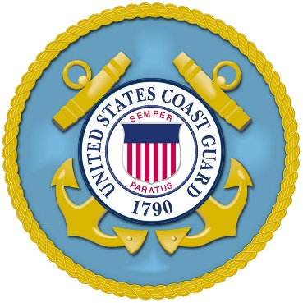

To all who shall see these presents, greetings:
Know Ye, that reposing special trust and confidence in the fidelity and abilities of this Petty Officer, I do hereby ceremoniously advance
First M. Last
To a Rating First/Second Class Petty Officer in the
UNITED STATES COAST GUARD
to rank as such from the
First day of Month, Two Thousand and Twenty One.
This appointee will therefore carefully and diligently discharge the duties of the grade to which appointed by doing and performing all manner of things thereunto pertaining. And I do strictly charge and require all personnel of lesser grade to render obedience to appropriate orders. And this appointee is to observe and follow such orders and directions as may be given from time to time by Superiors acting according to the rules and articles governing the discipline of the
Armed Forces of the United States of America.

Given under my hand at City, State, this First day of Month in the year of our Lord Two Thousand Twenty One.

____________________________

F. M. LAST

CAPTAIN, U. S. COAST GUARD

COMMANDER

UNIT

